Quantification of The Effect of Toxicants on the Intracellular Kinetic Energy and Cross-Sectional Area of Mammary Epithelial Organoids by OCT Fluctuation Spectroscopy

Xiao Yu,* Ashley M. Fuller,† Richard Blackmon,‡ Melissa A. Troester, §, ¶ and Amy L. Oldenburg*, ‡, ¶

Supplemental FIgures

Supplementary 3:
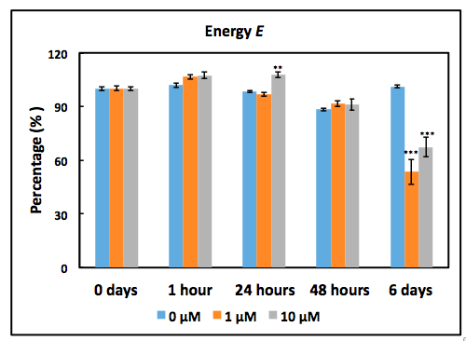
Dose-dependent responses of MCF10DCIS.com organoids to Dox as measured by the OCT-based E metrics. **p<0.001; ***p<0.0001 relative to the pre-exposure dose. Error bars represent mean + standard error.

Supplementary 4:
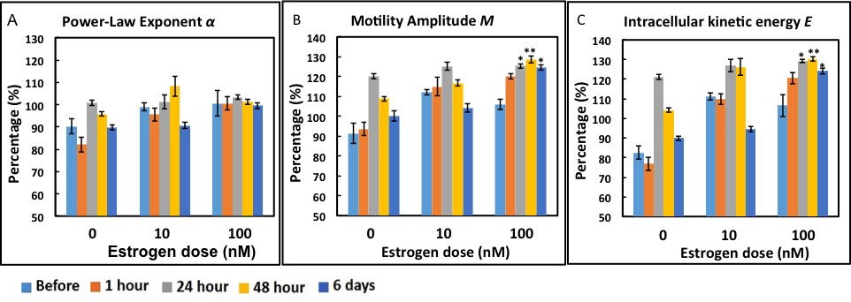
Time- and dose-dependent responses of MCF7 organoids to estrogen as measured by the OCT-based α (A), M (B) and E (C) metrics. *p<0.01; **p<0.001 relative to the pre-exposure time. Error bars represent mean + standard error.

Supplementary 5:
Time- and dose-dependent responses of MCF7 organoids to Tamoxifen as measured by the OCT-based α (A), M (B) and E (C) metrics. **p<0.001; ***p<0.0001 relative to the pre-exposure time. Error bars represent mean + standard error.

Supplementary 6:
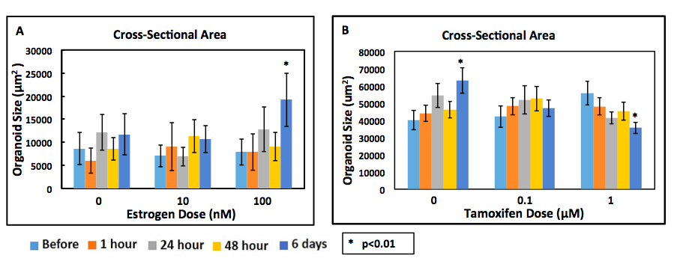
Time-course of measured MCF7 organoid CSA upon exposure to 17β-estradiol (A) and 4-OHT (B). *p<0.01 6 days relative to 0 days (before exposure). Error bars represent mean + standard error.

